The making of Boids simulation and investigation of their behaviours

Forest Li
In 1986, Craig Reynold, an expert in computer graphics and artificial life, released an artificial life simulation program named Boid, a ‘bird like artificial life’. In his essay ‘Flocks, Herds, and Schools: A Distributed Behavioural Model’ (Reynold, 1987), he gave a general description of behaviours of such creatures and how they end up with an overall movement of ‘flocking’. Upon watching the YouTube video “Coding adventure: Boids” (Lague, S., 2019), I found this topic interesting, not only because it simulates how animals like birds or fish behave in a group in real life, but also demonstrates the complex movements of the group while each individual follows simple rules. Inspired, I conducted further investigation to implement the Boid algorithm.

I have listed the objectives which I hope to achieve in this simulation:
- Having a complete implementation of the Boid algorithm.
- Attempting to optimize the algorithm without loss of accuracy.
- Developing further and exploring behaviours under different conditions.

- Implementation
The rules of the behaviour for each Boid are the sum of three vectors (Wikipedia contributor, 2019): alignment, cohesion, and separation. For each Boid, the acceleration vector is the sum of the following rules (Zandie, R. 2019):
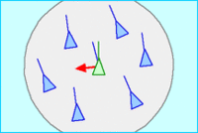
- Alignment: The Boid aligns with the other Boids around it.

$$a_{alignment}=v_{average}-v_{self}$$

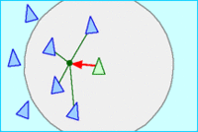
- Cohesion: The Boid moves toward the centre of the group of the other Boids
Figure 1: alignment

$$a_{cohesion}=p_{centreOfMass}-p_{self}-v_{self}$$

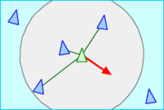
- Separation: Boid steers away from the other $n$ Boids in its view when they are close.
Figure 2: cohesion
Figure 3: separation
$$average=\frac{\sum_{i=1}^{n}{\frac{p_{self}-p_{boid}}{{|p_{self}-p_{boid}|}^{2}}}}{n}$$
$$a_{seperation}=average-v_{self}$$

And overall:

$$a_{self}={\hat{a}}_{alignment}×k_{alignment}+{\hat{a}}_{cohesion}×k_{cohesion}+{\hat{a}}_{seperation}×k_{seperation}$$

Where:

$$a=acceleration$$
$$v=velocity$$
$$k=scale$$

Sometimes as a result of addition, the acceleration becomes too large. I clamped the value using the method mentioned in “Flocking Behaviour Simulation: Explanation and
Enhancements in Boid Algorithm” (Sajwan, M., Gosain, D., & Surani, S., 2014). If the acceleration’s magnitude is larger than a maximum acceleration, the below calculation is carried out:
$$a=\frac{a}{|a|}×a_{max}$$

In order for each Boid to detect others in their field of views, the initial solution was to cast a few rays in a cone shape and detect any intersections. A mathematical method called ‘Fibonacci lattice’ (González, 2009) is implemented here to evenly distribute a sphere of n points which is essential for ray-casting. Using the implementation to algorithm by Robert, M (Robert 2020), the position for each of individual point $i$, of a total $n$ points evenly distributed on a sphere is given by:

$$\left(x_{i}, y_{i},z_{i}\right)=\left(\cos\left(\frac{2iπ}{ϕ}\right)×\sin\left(θ\right), \sin\left(\frac{2iπ}{ϕ}\right)×\sin\left(θ\right),\cos\left(θ\right)\right)$$

Where:
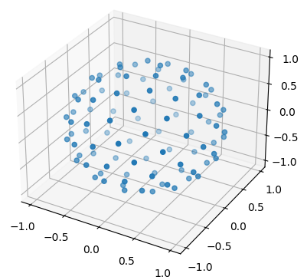
$$Φ={\frac{1+\sqrt{5}}{2}}$$
$$θ=\cos^{-1}\left(1-\frac{2×(i+0.5)}{n}\right)$$
Figure 4: Fibonacci lattice generated from python matplotlib.
$\%1$ operator here denotes the ‘fractional part of the argument’. Eventually, $n$ points are evenly generated on the surface of the sphere, as shown in figure 4. Dividing $n$ by a portion number, we achieve a cone shaped viewing zone.

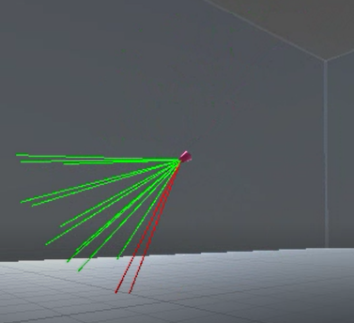
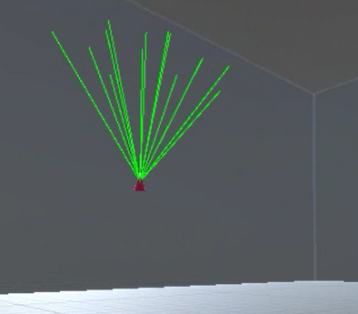
The viewing zone affects separation vector of the Boid, but the same formula can also be used to simulate obstacle avoidance, steering away when detecting obstacles, as shown in figure 5.
Figure 5: Object avoidance，Boid steers away when detecting obstacle.

- Optimization
Although the idea of ray-casting to create cone-shaped view zone is intriguing, casting about 20 to 30 rays for each of the Boids and repeating the same action in every frame can be extremely inefficient. Currently, my laptop can only simulate a maximum of 100 Boids simultaneously, and the Frame rate is capped at 20. To further improve the performance, a better view algorithm is required. My first thought was to simply loop through all the Boids, and for each one, calculate whether they are in view. The detail of how this is achieved is illustrated in figure 6.

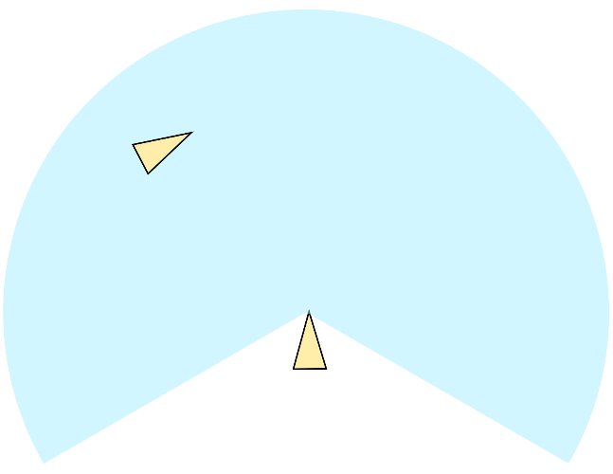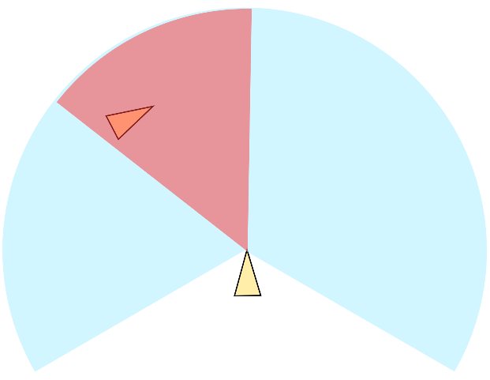
$$θ$$
$$Distance$$
$$d=p_{target}-p_{self}$$
$$θ=\cos^{-1}(\frac{v_{self}∙d}{|v_{self}||d|})$$
$$Distance=|p_{self}-p_{target}|$$

Figure 6: If the distance between two Boids is less than the maximum viewing distance (indicated by the radius of blue sector), and the angle between two Boids is less than maximum viewing angle (proportion of the blue sector), then the Boid is in view. This can be applied to 3D with the same operation.

However, performing this calculation requires the algorithm to loop through all the Boids. This, again, becomes performance heavy since the processor (CPU) needs more time for more operations . To overcome this problem, I implemented a space partitioning algorithm, which simply slices space into cubical cells. Each Boid is assigned with a vector of three integers, calculated via the line of code:
where math.floor is a function returning the integer part of a decimal number. In this way, Boids are all classified into “cells”. The returned value of this function is then used as key in a multi map, a map where multiple values may be associated with one key as shown in figure 7. So, a Boid only need to loop through the other Boids positioned in the same cell or the near 26 cells (presented in figure 8) and check if any of them are in view. This will be much faster than any of the previous methods.
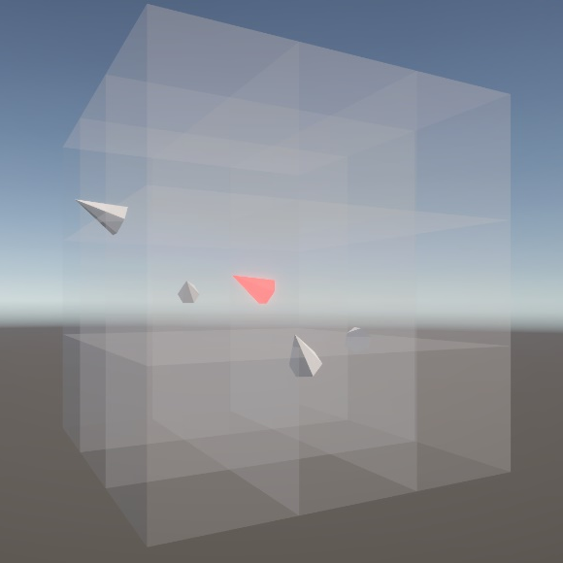

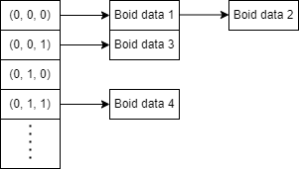

Figure 7: the structure of a multi map. More than one values (or no values at all) can be set to one single key. Data stored in the same key will be read one by one.
Figure 8: the 27 cells that the current Boid (in red) need to loop through to check whether the other Boids are in view or not.

Apart from the algorithmic improvement, I also discovered an entirely new way of programming in Unity: Data Oriented Technology Stack (DOTS) (Unity Learn, n.d.). This is completely different from the object orientated monobehaviour scripts, where data and behaviours might be stored together. Instead, data about an entity is stored in “component” script and actions are stored in “system” script. This style of coding allows Unity to assign parallel “jobs” to each thread in the CPU, making the execution speed dramatically faster. I changed all my code from object-orientated to data-orientated and implemented the above algorithm. Instead of 100, these optimizations allow my CPU to simulate around 10,000 Boids simultaneously with a similar Frame rate.

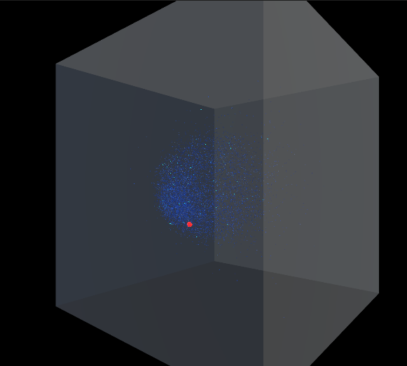
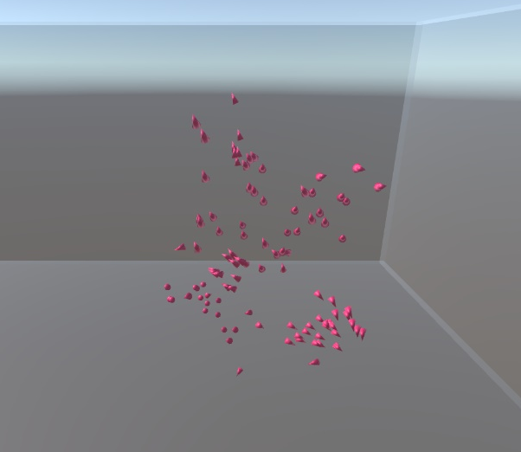
Figure 9: from 100 Boids (left) to 10,000 Boids (right).

- Analysis
A transparent box is constructed to contain all the Boids. An appropriate set of values for the variables was found which enable Boids to traverse the box as flocks. Since the flocks do not have a clear destination, I added a target (sphere in red) for the Boids to fly toward when they detect it. The variables were then adjusted to investigate the changes in Boids’ behaviour as a group:

- Increase alignment scale, $k_{alignment}$: Boids adjust much faster when the leading Boid has a change in velocity. This results in larger group of Boids heading toward the same direction, and less individual Boid left alone (figure 10). The magnitudes and directions of their velocities in a flock are similar. 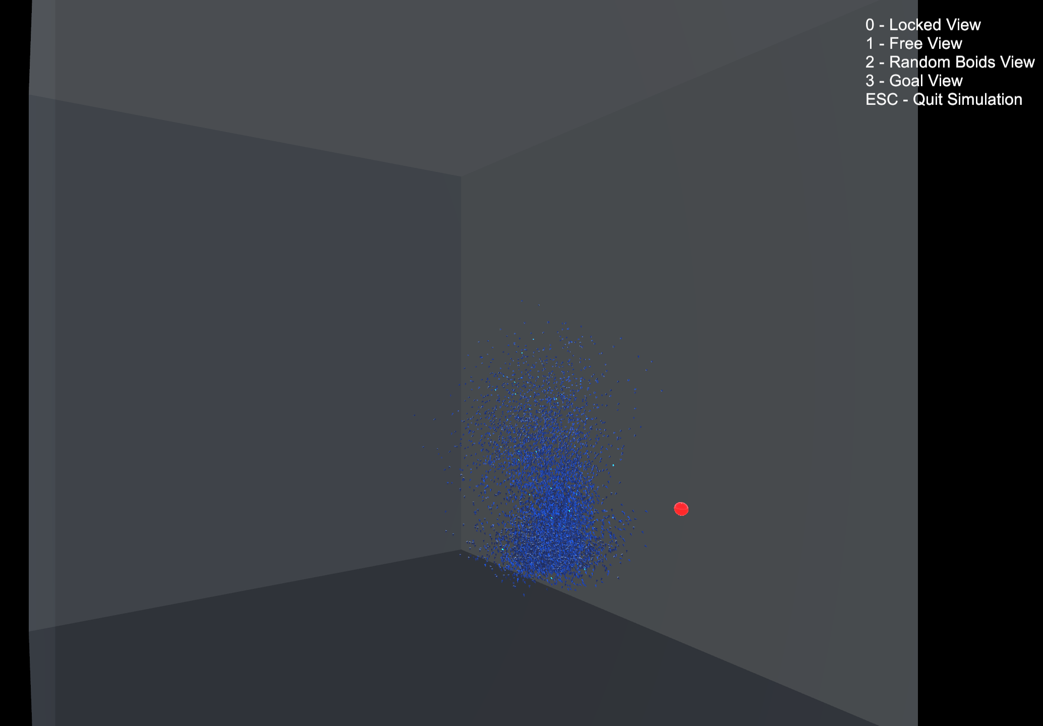
Figure 8: increased alignment scale.
- Increase cohesion scale, $k_{cohesion}$: again, Boids stay in a larger group as there is a reduced spacing observed between each Boid. However, there is reduced sense of direction for the group as whole, since they are unable to escape the attraction towards each other (figure 9). Flocks are simply centred together around the target.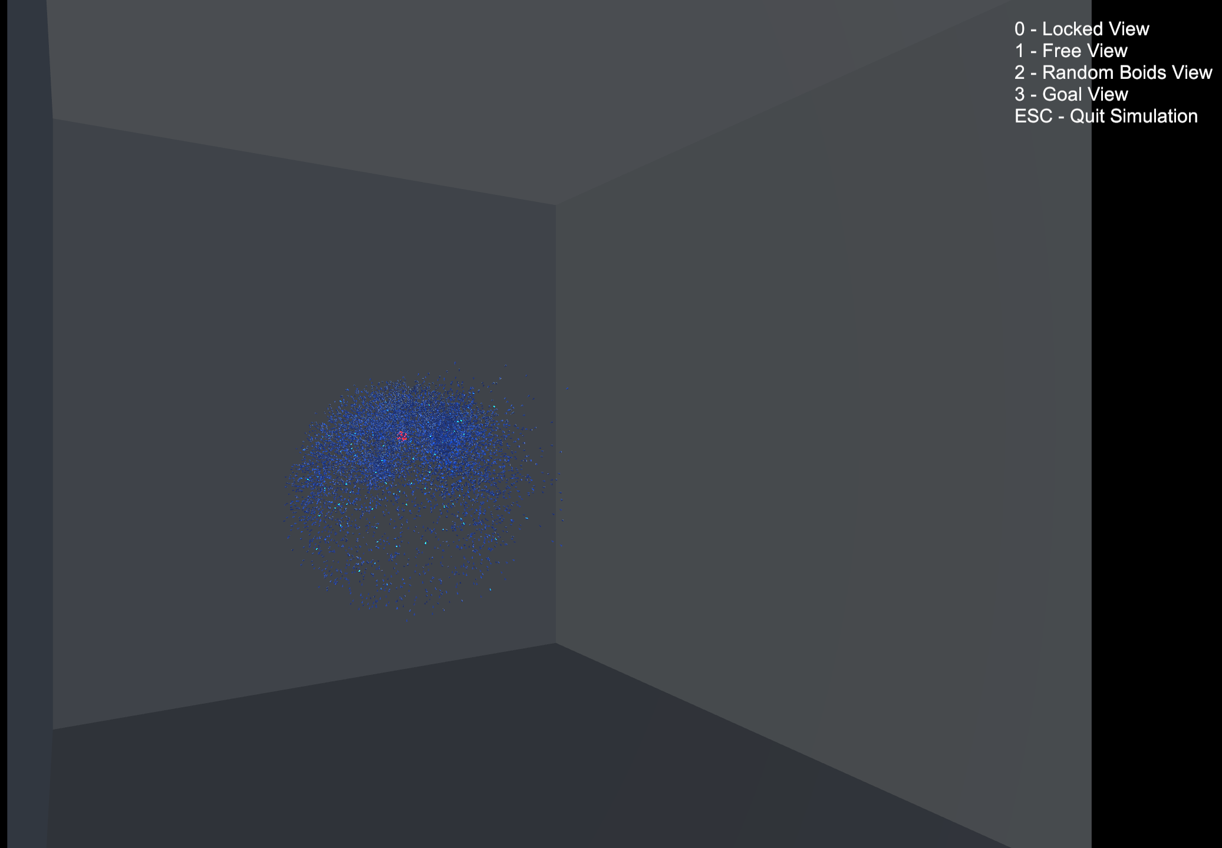
Figure 9: increased cohesion scale
- Increase seperation scale, $k_{seperation}$: Despite the fact that some Boids are gathered around the target, very little flocking behaviour is observed as each Boid accelerates outwards from the center of the flocks (figure 10). The Boids quickly fill the whole box.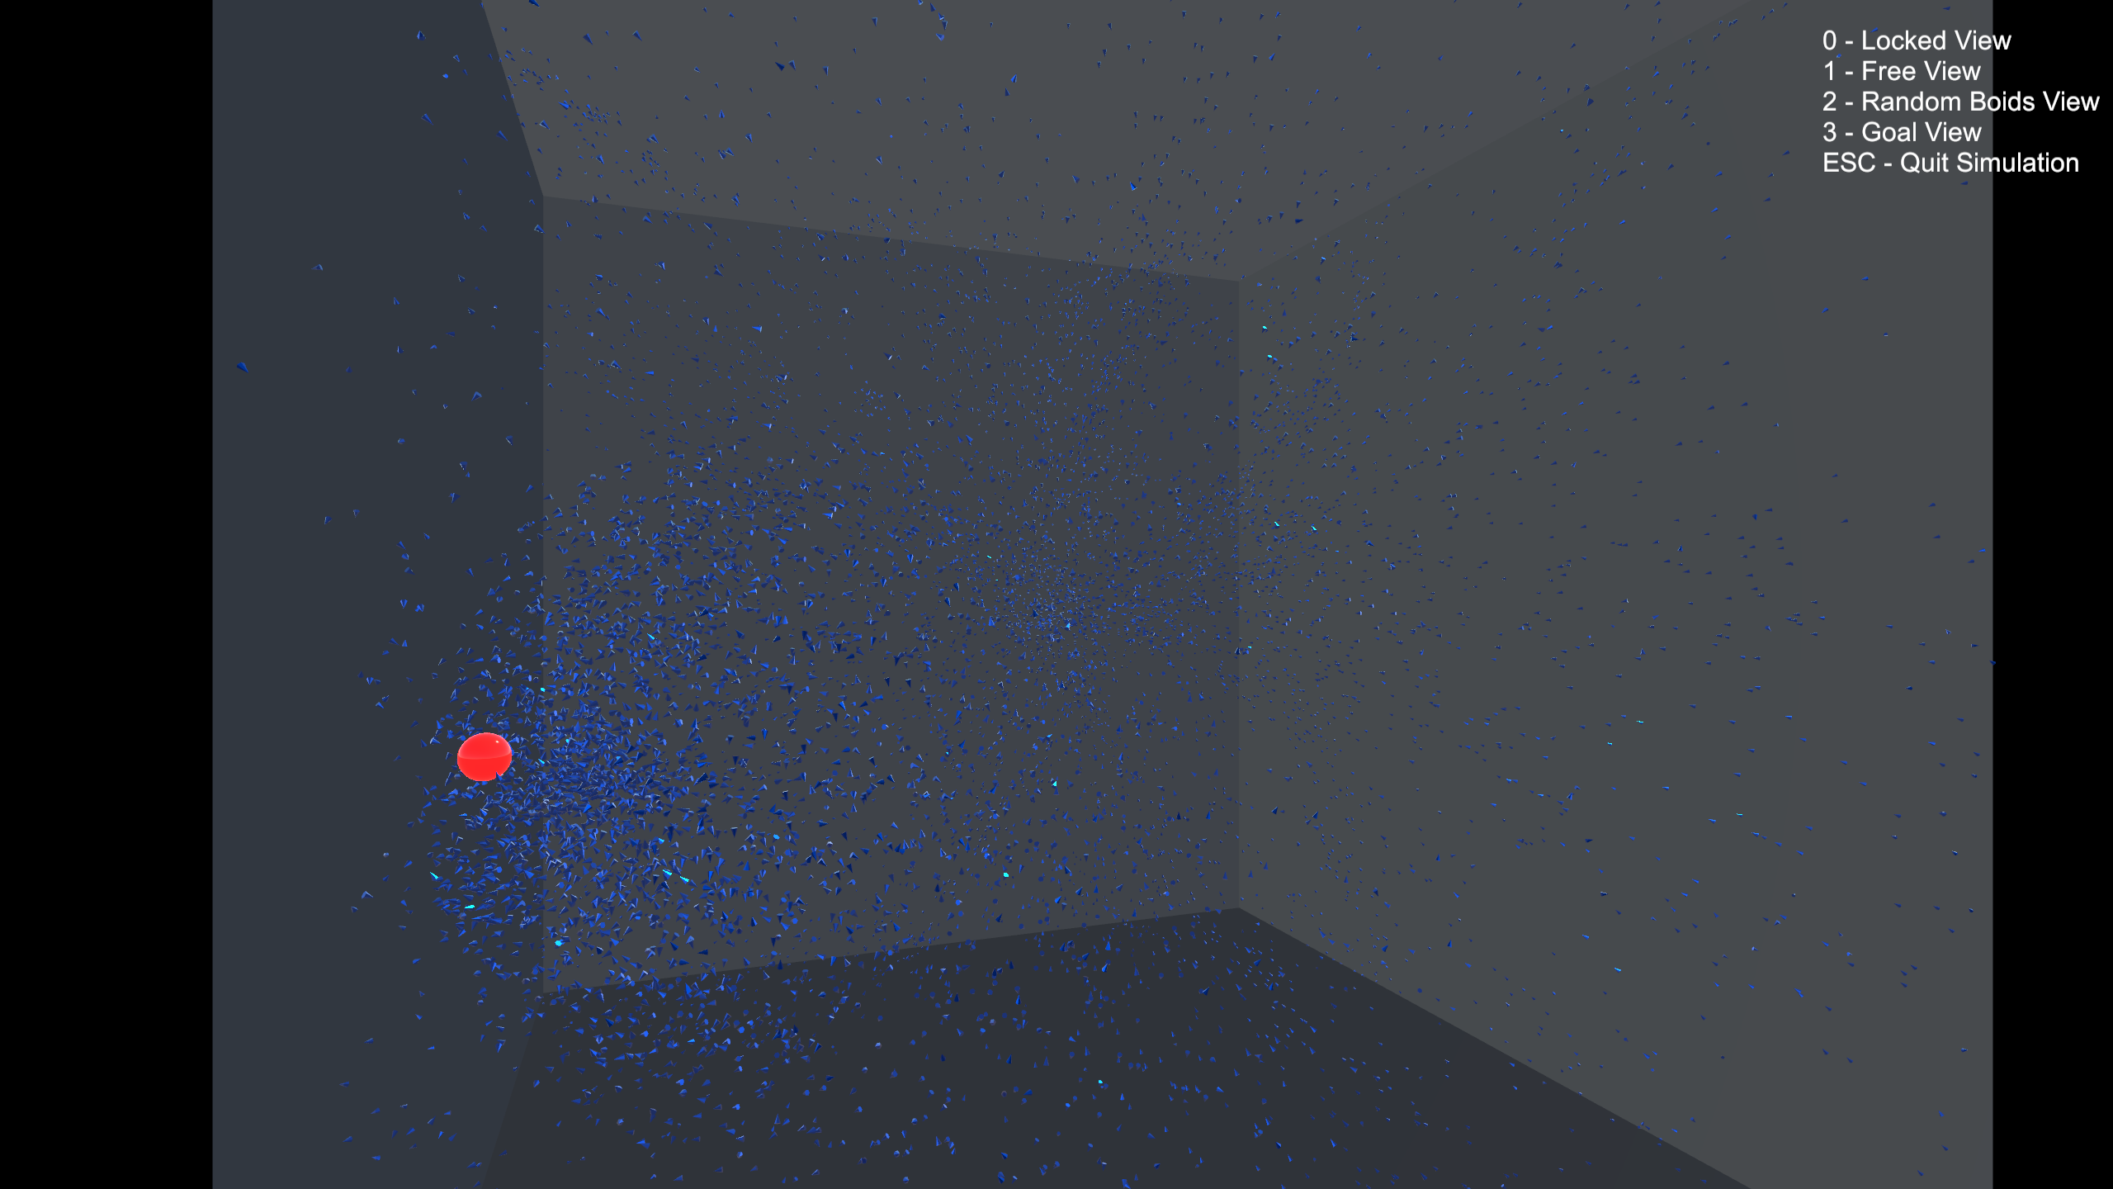
Figure 10: increased separation scale.

Obstacle avoidance is also implemented with a very similar procedure to separation: if any obstacles are detected, steer away from it depending on the distance. The closer the Boid is towards obstacle, the more it turns away. Figure 11 has demonstrated this.
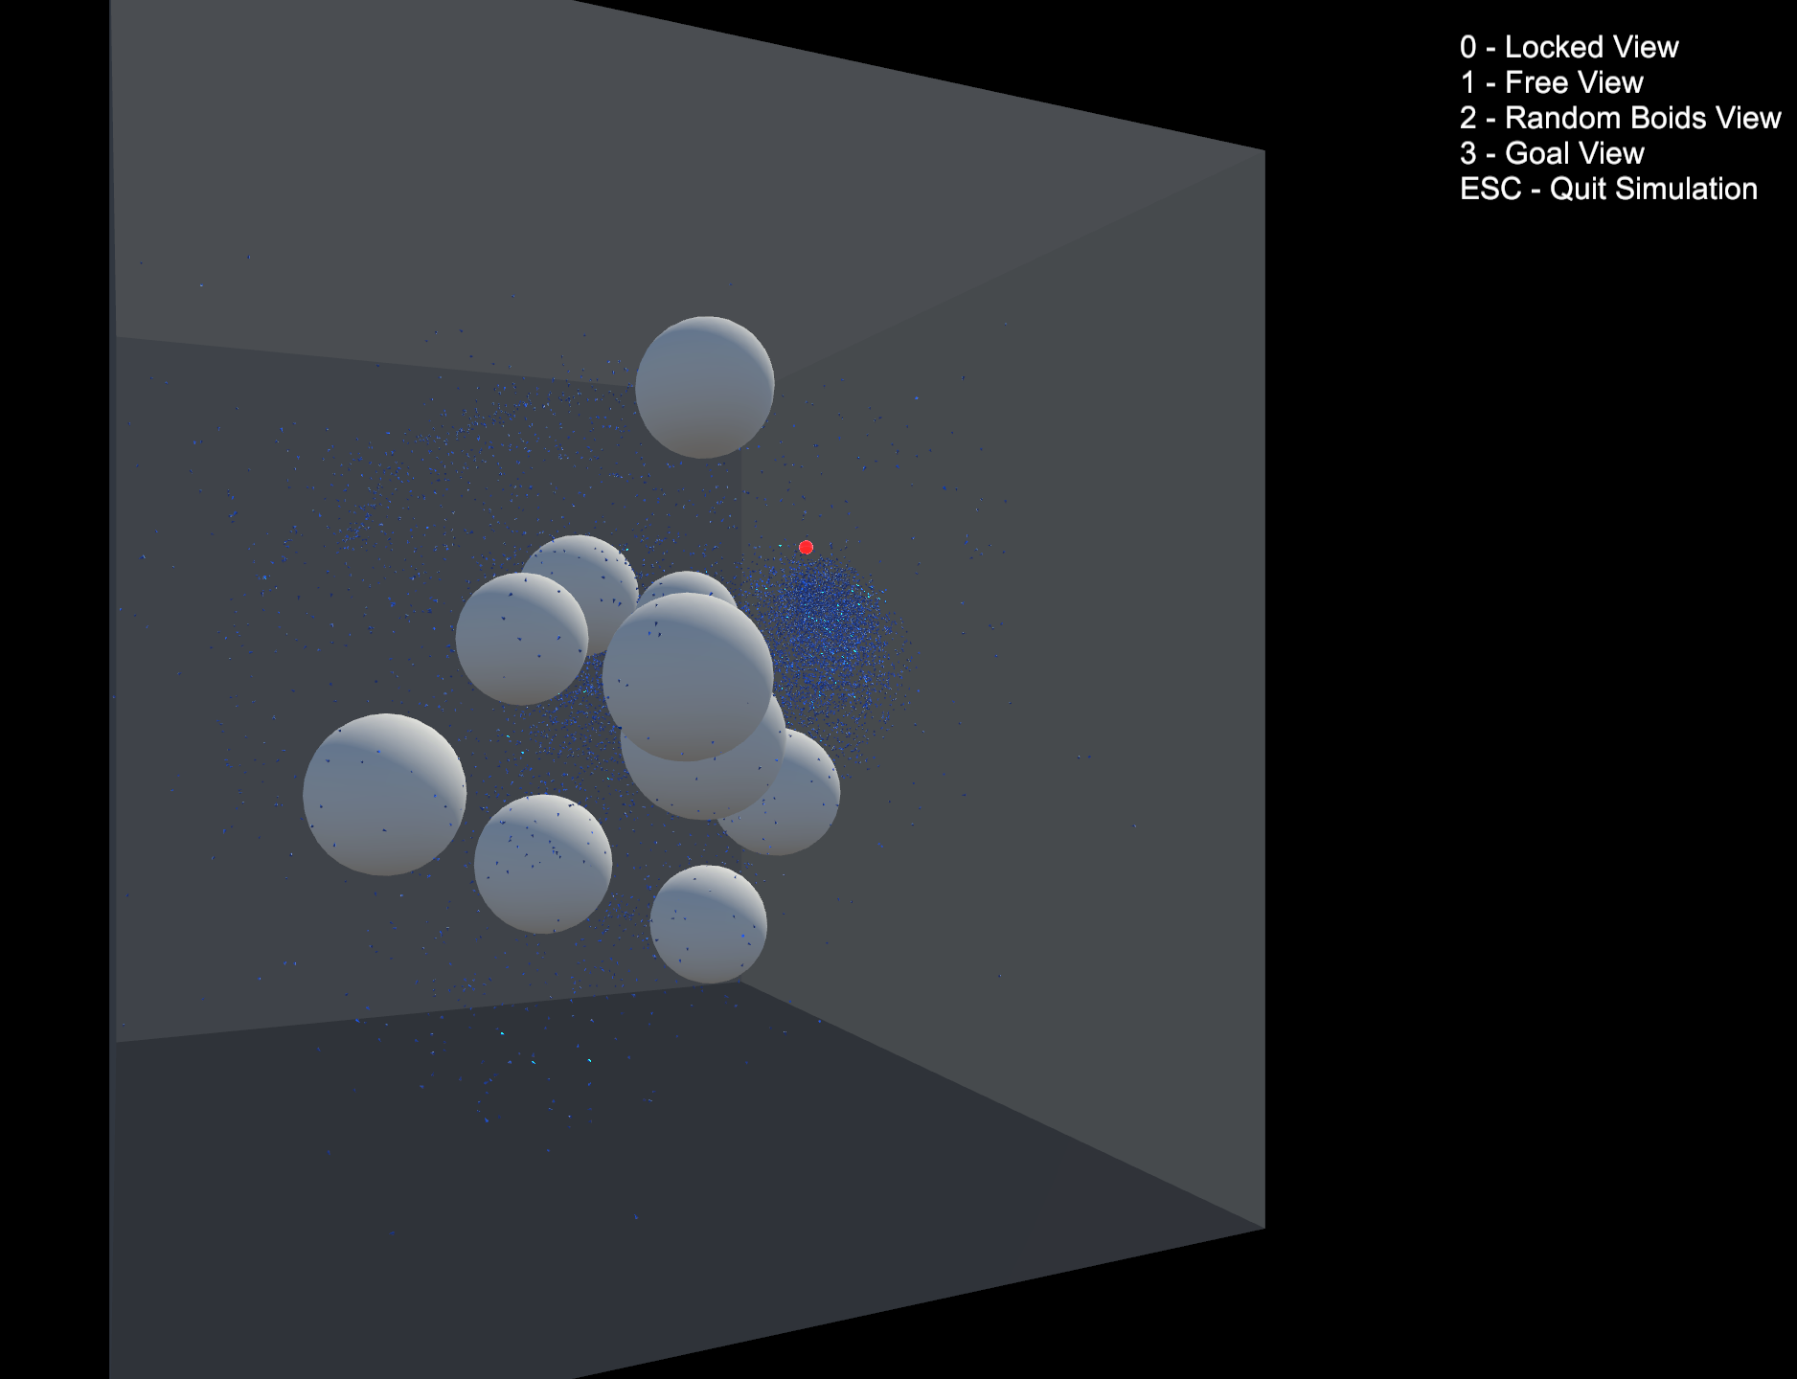
Figure 11: Boids try to avoid obstacles near them and turning away when detecting walls.

There are plenty of more variables involved in this simulation. For example, the viewing distance and viewing angle of individual Boid, number of obstacles and so on. Adjusting any of the parameters might result in a complete different flocking behaviour (Sinkovits, D., 2006). Therefore I created a graphical user interface for the users of this simulation to adjust the variables themselves. This makes the simulation more easy to use and understand.

- Evaluation
The program is able to simulate the flocking behaviour of particular creatures in nature including birds and fish. The optimization approach has boosted the number of Boids by 100 times. The implementation of UI makes the simulation easy to use and understand.

However, despite the fact that the algorithm can already simulate over 10,000 Boids, this might not be the most optimized approach. Currently the whole program uses CPU to create instances, but a better method could be to implement it with GPU code (Husselmann and Hawick, 2011) (9. Erra, U., De Chiara, R., Scarano, V., & Tatafiore, M., 2004). This could potentially speed up the program even more because of the parallel nature of GPU, but the result might be unreliable since only a few GPUs (for example, NVIDIA GPU with CUDA toolkit installed) support this type of operation.

The space-partitioning method seems to be a good solution in most situations. However, when increasing the cohesion or alignment scale, the Boids become more concentrated in some areas. This increases the number of Boids which need to be looped through every frame and results in a decrease in frame rate, since they are all in the same cell. I have done research into other methods like Z-buffering (Wikipedia, 2021) and quad trees (Samet, H. 1984), but none of these solve the problem. This could be my area of future research.

- Conclusion
In general, I have set myself some objectives at the beginning of the project. I think it is worthwhile to list them here and evaluate how well I did to achieve those goals:
- Having a complete implementation of the Boid algorithm: I have had a very complete algorithm of basic Boid flocking behaviours. I also extended this task and implemented the object avoidance function for each Boid.
- Attempting to optimize the algorithm without loss of accuracy: I have upgraded my algorithm several times in attempt to optimize the algorithm and get a better performance. After upgrading the Boid viewing function and implementing space-partitioning algorithm and DOTS, there is an obvious performance boost. However, I believe the algorithms can be further optimized via other approaches.
- Developing further and exploring behaviours under different conditions: I have observed the different grouping behaviour by changing variables of the system,
- for example, alignment, cohesion and separation scales. Furthermore, I created a graphical user interface for the user to adjust variables themselves.

- Future Work
The algorithm is not yet optimized to its full potential.

The Reynold’s approach is not the only approach to achieve flocking behaviour of a group of Boids. There are other types of flocks including cluster flock and line flock (Beaver, L. E., & Malikopoulos, A. A., 2021). It could be interesting to explore those other approaches in the future.

There are many other applications of the Boid algorithm. Upon reading “Optimisation of Boids Swarm Model Based on Genetic Algorithm and Particle Swarm Optimisation Algorithm (Comparative Study)” (Alaliyat, Yndestad and Sanfilippo, 2014), I was introduced to the genetic algorithm (GA) where Boids update their steering weight based on simulated natural selection. This could be an interesting direction to go since the program simulates the process of evolution. In the physical side, Boid algorithm can also be used for deigning multi-robots system (Beaver, L. E., & Malikopoulos, A. A., 2020, December).

Overall, making and investigating the Boid simulation has been fascinating, but also challenging. Many problems have arisen during the programming, and it has been very interesting, and rewarding, to solve them. Besides the beautiful movement of the flocking behaviour, what is truly fascinating, in my opinion, is how simple rules of individual Boid combines to form a much more complex and intellegent behaviour as a group.
References:
- Reynolds, C.W. (1987). Flocks, herds and schools: A distributed behavioral model. ACM SIGGRAPH Computer Graphics, [online] 21(4), pp.25–34. Available at: https://www.csee.umbc.edu/~adamb/435/Reynolds-1987-FHS.pdf [Accessed 30 Oct. 2021].
- Wikipedia Contributors (2019). Boids. [online] Wikipedia. Available at: https://en.wikipedia.org/wiki/Boids.
- Zandie, R. (2019). Simulating Bird Flock Behavior in Python Using Boids. [online] BetterProgramming. Available at: https://betterprogramming.pub/boids-simulating-birds-flock-behavior-in-python-9fff99375118 [Accessed 30 Oct. 2021].
- Roberts, M. (2020). How to evenly distribute points on a sphere more effectively than the canonical Fibonacci Lattice | Extreme Learning. [online] Extreme Learning. Available at: http://extremelearning.com.au/how-to-evenly-distribute-points-on-a-sphere-more-effectively-than-the-canonical-fibonacci-lattice/ [Accessed 30 Oct. 2021].
- González, Á. (2009). Measurement of Areas on a Sphere Using Fibonacci and Latitude–Longitude Lattices. Mathematical Geosciences, [online] 42(1), pp.49–64. doi:10.1007/s11004-009-9257-x.
- Alaliyat, S., Yndestad, H. and Sanfilippo, F. (2014). Optimisation of Boids Swarm Model Based on Genetic Algorithm and Particle Swarm Optimisation Algorithm (Comparative Study). [online] ECMS. Available at: https://citeseerx.ist.psu.edu/viewdoc/download?doi=10.1.1.1062.9422&rep=rep1&type=pdf [Accessed 24 Aug. 2022].
- Sajwan, M., Gosain, D., & Surani, S. (2014). Flocking behaviour simulation: Explanation and enhancements in boid algorithm. International Journal of Computer Science and Information Technologies (IJCSIT).
- Husselmann, A. V., & Hawick, K. A. (2011, April). Simulating species interactions and complex emergence in multiple flocks of boids with gpus. In Proc. IASTED International Conference on Parallel and Distributed Computing and Systems (PDCS 2011) (pp. 100-107).
- Erra, U., De Chiara, R., Scarano, V., & Tatafiore, M. (2004). Massive simulation using gpu of a distributed behavioral model of a flock with obstacle avoidance. Proceedings of Vision, Modeling and Visualization 2004 (VMV).
- Sinkovits, D. (2006). Flocking behavior. Semabtic Scholar, 1-10.
- Wikipedia. (2021). Z-buffering. [online] Available at: https://en.wikipedia.org/wiki/Z-buffering.
- Samet, H. (1984). The Quadtree and Related Hierarchical Data Structures. ACM Computing Surveys, 16(2), pp.187–260. doi:10.1145/356924.356930.
- Beaver, L. E., & Malikopoulos, A. A. (2021). An overview on optimal flocking. Annual Reviews in Control, 51, 88-99.
- Beaver, L. E., & Malikopoulos, A. A. (2020, December). Beyond Reynolds: A constraint-driven approach to cluster flocking. In 2020 59th IEEE Conference on Decision and Control (CDC) (pp. 208-213). IEEE.
- Lague, S. (2019). Coding Adventure: Boids. [online] www.youtube.com. Available at: https://www.youtube.com/watch?v=bqtqltqcQhw.
- Unity Learn. (n.d.). What is DOTS and why is it important? [online] Available at: https://learn.unity.com/tutorial/what-is-dots-and-why-is-it-important?language=en#.

